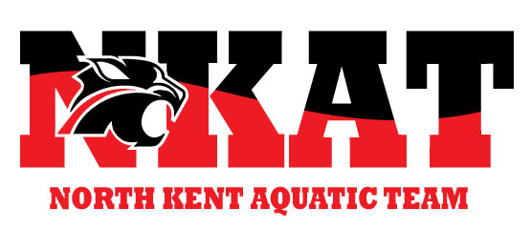
NKAT Q&A
Updated 1-12-22
Questions regarding NCST / NKAT Swimming can be directed to NCST/NKAT Swimming team administration at https://www.teamunify.com/team/minkat/page/system/contactus we will respond within 24-48 hours.
What is your COVID quarantine policy
We follow the recommendations of the Kent County Health Department and CDC and align with Northview Public Schools. Please click on this link for contact tracing and quarantine recommendations: https://nvps.net/covid-19/
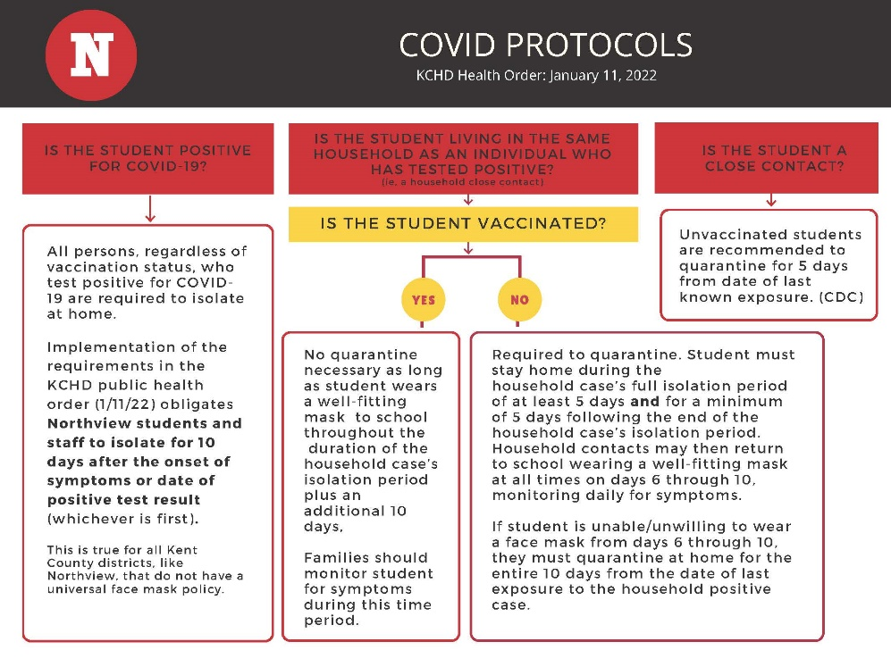
COVID positivity rates are extremely high in the community at this point in time. We are asking that you keep your athlete at home if they have any symptoms of COVID-19 including;

- Cough or tightness in your chest or difficulty breathing
- Sore throat, nasal congestion
- Nausea or vomiting, headache
- Fever
- Headache, muscle aches or weakness
- Loss of taste or smell

There have been a lot of changes to CDC guidance and different schools following different guidance on quarantine, so we wanted to be sure it was clear what our policy is.

Positive Swimmer: If your athlete tests positive for COVID-19 they are not allowed to attend swim practice for 10 days. Although the quarantine period has been reduced to 5 days, and then 5 additional days in a mask, this is only if people can safely be masked for the second 5 days which is not possible in swimming.
Please notify us if your athlete does test positive with the following information; date of symptom onset or positive test, last day they were at practice, the group they are in and date of return to practice/competition.

Close Contact: If your athlete is fully vaccinated or has had a confirmed diagnosis of COVID-19 within the past 90 days and does not have symptoms concerning for COVID-19, then your athlete is not recommended to quarantine. If your athlete is not fully vaccinated, the CDC recommends a five-day quarantine beginning with the most recent date of exposure. This is in keeping with current practice of NVPS our host site.

Again, given the rate of COVID positive cases in the community we are all likely being exposed daily, your diligence in monitoring for symptoms and keeping your athletes home when they don't feel well is imperative to keeping our kids safe and in the water.

How are you handling close contact notifications?

On January 11, 2022, the Kent County Health Department issued its most recent Public Health Order regarding COVID-19. Pursuant to the January 11 order, the individual contract tracing process for students/athletes in grades 7-12 will no longer include an individual communication to families if there has been a 'close contact' at swimming.

Despite all efforts, you can assume that we all may come into contact with a COVID-positive person throughout the course of the school day, extra-curriculars/sports, and social/work activities. Individuals may be asymptomatic or otherwise not even know that they are sick with the virus. Please continue to monitor and test athletes if you see symptoms and stay home when sick.

For athletes in 6th grade and below, we will continue to notify families via email when their athlete has a confirmed case they were a contact of. We ask that all families and athletes continue to routinely monitor for symptoms and stay home when sick.

What’s the difference between NCST and NKAT?
NKAT Swimming offers both a USA level program that has more frequent/longer practices and a different set of expectations as well as a community based (NCST, non-USA) league. If you are looking for a higher level of training/competition, you should consider NKAT USA. Both offer a fall/winter and spring/summer option – the community-based season is usually shorter.
Can you participate in NKAT Swimming as well as another sport simultaneously?
While we do encourage this, the decision will be made between the coach and the swimmer/family. NKAT Swimming offers a Multi-sport athlete membership option most sessions.
Is NCST/Community Swim going away?
No, we will always have the community-based swim program at NKAT Swimming designed to create opportunities for all levels of swimming. We are committed to being a welcoming place for swimmers of all experience, skill, and ability levels.
What is the coaching philosophy of NCST/NKAT?
- To give athletes, coaches, and parents a positive experience in the sport of swimming
- Keep athletes and parents engaged in the sport.
- Expose more youth to the sport of swimming.
- Teach athletes life skills that can be taken into everyday life.
- Swimmers first/athlete focused; support our athletes throughout their swimming journey.
- Technique, technique, technique
- All swimmers are coached in all strokes and their fundamentals until the swimmer shows a proclivity to specific stroke or stroke.
- Quality coaching focused on the four critical athlete centered outcomes of: competence, character, confidence, and connection.
What will pricing be?
Basic pricing is structured around the length of season and the number of swimmers per group.
What is the refund policy?
Northview Community Swim Team/North Kent Aquatic Team has adopted the following refund policy. Refunds only apply to session fees. Any other expenses are non-refundable (suits, caps, gear, meet fees, etc.)
Prior to start of session-First week of session (First 7 days)- 100% refund given minus a $10.00 processing fee (fee covers use of the web provider payment services) OR a credit toward a future session (no processing fee applies).
Second week of the session (Day 7-14)- 50% refund will be given OR 50% credit toward a future session.
Week three of the session (Day 15 +) NO refunds after the second week of the session.
After 14 days, a refund or credit MAY be issued for certain extenuating circumstances (job transfer, major injury, surgery, etc.). Requests must be submitted in writing to nkatbillilng@gmail.com. Requests will be reviewed on a case-by-case basis and prorated for time used. No refunds will be issued for voluntary removal from the program.
All refund/credit requests must be in writing to nkatbilling@gmail.com within the stated time frame.

What is Team Unify?
Team Unify is our “one stop shop” site where you can access team information, practice/meet schedules and volunteer and refund policies. This is also where you register for meets and the program.
What is the website and social media pages?
Our new website www.Nkatswimming.org will take you to team unify.
Our Facebook page remains as https://www.facebook.com/northviewcommunityswimteam/
Do athletes, coaches, and families need to wear masks?
We will follow the guidance from Northview Public Schools as well as the MDHHS at all times. Please keep in mind that the recommendations may change. At this point, all athletes in grades pre-K – 6th as well as their coaches will need to wear a mask at all times on the pool deck and during dry land practices.
How many people can be in a lane max?
There is no max per lane based on present guidelines.
What are the group sizes?
We will have 6-10 lanes open depending on concurrent programming in the pool .

What is “365 swim plan”?
Where you are training throughout the whole year (i.e., have a 365-day plan for swim seasons, off seasons, and down time or rest). At a varsity or advanced level, kids with a 365 plan are better able to compete at the high level.

What are the major changes you will see in NCST?
There are dedicated swim days now as opposed to being able to swim any day of the week. This follows the American Development Model for swimming which provides suggested frequency and duration of practices for our kids. It allows us to offer more practice groups to more kids, maximize pool time and schedule coaches more appropriately.
How will this work with Middle School / High School
We definitely want to encourage the Middle and High school kids to swim with their school teams. They can practice with NKAT Swimming when the season is done or if they want a little more training during the season. At the end of the season, they can fully jump back into the program. You may also participate in 2 USA meets during your school season if you are a USA Swimming member athlete.

Do I need my own equipment?
We highly encourage obtaining your own equipment but will continue to have equipment available for use at the pool. We have a list of recommended equipment by group level on our website. https://www.teamunify.com/team/minkat/page/documents
What are the levels of swim?
The levels are listed here: https://www.teamunify.com/team/minkat/page/team-registration

